Congue nihil imperdiet doming id quod mazim placerat facer minim veni am ut wisi enim ad minimeniam, quis erat nostr uexe

rci tation ullamcorper nostru exerci tation ullam corper et iusto odio dig nissim qui blandit praesent lupta. Tummer delenit

augue duis dolore te feugait nulla facilisi. Con erattis sectetuer adip iscing elit, sed erat diam nonummy nibh magna erat.

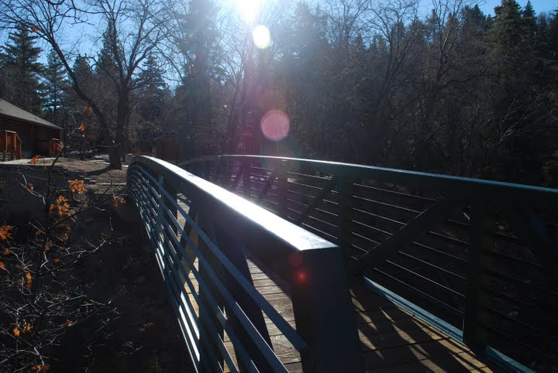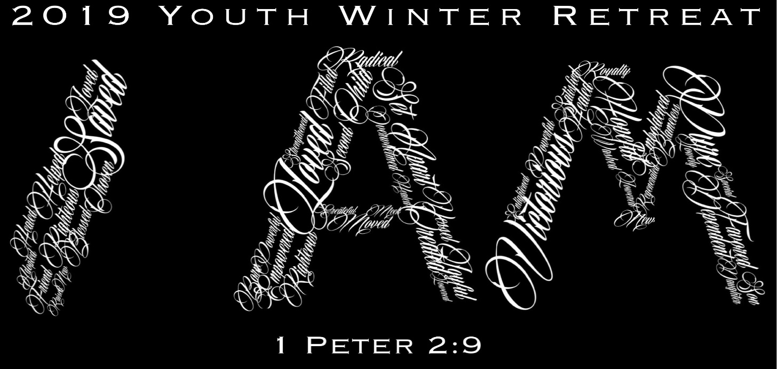

Green Valley Lake Christian Camp  
(formally known as Calvary Chapel Christian Camp)

Contact Numbers

**ABOUT:**  
To create an atmosphere where  people come from all walks of life, to be refreshed. A place where recreation, God’s creation, the word of God, and worship, all combine in leaving a lifelong impact on the soul of each camper.

**EXPECT:**  
When you arrive at Green Valley Lake Christian Camp, you should expect to have your life touched by the power of the Holy Spirit. With the combination of spiritual worship, great Bible studies, good food, and outrageous activities, you can expect to be extremely blessed. Our staff will do all that they can to see that every need you have will be met with a servant’s heart. If at the end of your retreat you leave having experienced a touch from the Lord, then we have done what God has called us to do.

The Retreat has asked us to inform you, that if you would like to contact your child, please call/text these numbers first, before calling the Retreat. *(This goes for all situations)*

**- Jonathan (CCLW Youth Pastor)-951.660.1204**

- **Evangelina (CCLW Girls Youth Leader)-951.314.6807**

**-**

**-**

**Calvary Christian Camp:** 909.867.4444

WEB-SITE info:  
www.livingwatercorona.com/IAM  
[www.facebook.com/ccyouthwinterretreat](http://www.facebook.com/ccyouthwinterretreat)

Departure & Arrival Plans:

What to B**ring**:

When Is It?

Please plan accordingly concerning when to be dropped off for the Retreat, & when to be picked up.

Arrangements should be made prior to the day of the RETREAT, to arrive at church at an appropriate time to get to the Retreat. Please ensure you are on time to church, so that we can leave at a descent time.

So, please pack the night(s) before the retreat, and make the proper arrangements

The sooner our group leaves, the better! Think about others, in this aspect… in the sense… don’t make the whole group wait for YOU! Also, consider…if the group arrives late… NO DINNER will be PROVIDED on FRIDAY NIGHT! Please don’t be the reason for everyone NOT EATING!

Also… you will arrive back at your church at approximately **1230pm** on **Sun** (Jan27th)

Please make the proper arrangements to be picked up by your parents.

Jan 25th -Jan 27th

🞎Complete Medical Release Form *(for all participants 17 & younger)*

🞎 Bible-*other then the one on your phone*

🞎 Sleeping Bag & 1 Duffle Bag

🞎 Winter Jacket & Clothes

🞎 Toothpaste & Toothbrush

🞎 Towel

🞎 Soap & Shampoo

🞎 Pillow

🞎 Pajamas  
🞎 Tennis Shoes &/or Snow-Waterproof Shoes  
🞎 Team Color Clothing to be worn on Saturday

**Suggest things to Bring**  
🞎 Camera

🞎 Backpack

🞎 Flashlight

🞎 Hat &/or Beanie

🞎 Chap Stick

🞎 Extra Socks

🞎 Spending Money for Group Picture ($6) & for Snack Bar ($20-$30)

***-Suggest that belonging be marked & Identified by adding one’s name onto property  
-When Packing Clothes, please insure that none are profane &/or provocative  
-When packing, please remember that it will be cold, so please pack appropriately. And also, space in vehicles is limited… so please only pack for 2 full days!***

Open to all 6th-12th Graders

*We also ask Adults to pray about joining us to help as Chaperons, Counselors &/or Drivers*

Who Can Go?

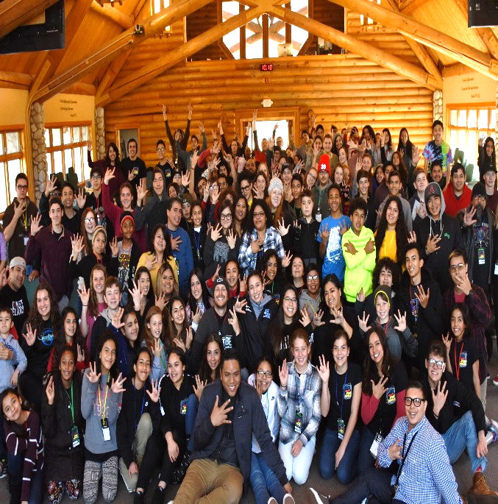

**What NOT to Bring/Do**

The following ABSOLUTES are cause for immediate removal from the camp. In extreme cases we may call local law enforcement, along with PARENTS WILL NEED TO PICK UP CHILD:  
- No DRUGS  
-NO ALCOHOL  
-NO VULGAR LANGUAGE  
-NO FIRE of any KIND  
-NO WEAPONS of any KIND  
-NO PUBLIC DISPLAY of AFFECTION (NBC RULE)  
-NO GUYS in the GIRLS DORM or GIRLS in the GUYS DORM  
-NO PRACTICAL JOKES  
-NO STEALING  
-NO DESTRUCTION of CAMP PROPERTY  
**- CELL PHONES can be used during certain times. When in teaching Sessions however, please insure that they are properly put away, so as to not be distracted/distraction.**

Our heart at this year’s RETREAT, is to challenge, encourage and equip those who attend, to be able to lay aside any “**Label**” that they may have allowed others or even themselves to have their lives “**Defined**” by… and truly look to God & His wonderful Word, and see what He thinks and is creating us to be. So we can truly no longer be “Labeled” & “Defined” by society, but truly say like **1 Peter 2:9**, that **I AM “a chosen generation, a royal priesthood, a holy nation, His own special people…”**

Cost is $137 per person

How Much is It?

**Green Valley Lake Christian Camp**

32355 Green Valley Lake Road •

Green Valley Lake   Ca • 92341

**Phone:** (909) 867-4444

Where is It?

Purpose